COMPLEXITY:

1. Run Time Complexity:
- Different solutions or algorithms can be used to solve a problem.
- Run Time complexity of an algorithm describes the complexity of an algorithm.
- It answers question like: How much processing time or power is required to run the algo if we increase the input?

- Complexity can be:
a) Linear: When the number of things we have to do is directly proportional to the number of input.
b) Quadratic: When the number of things we have to do increases significantly when the number is increased, like N^2 (nested for loop) is an example of quadratic run time.

2. Most common run times:
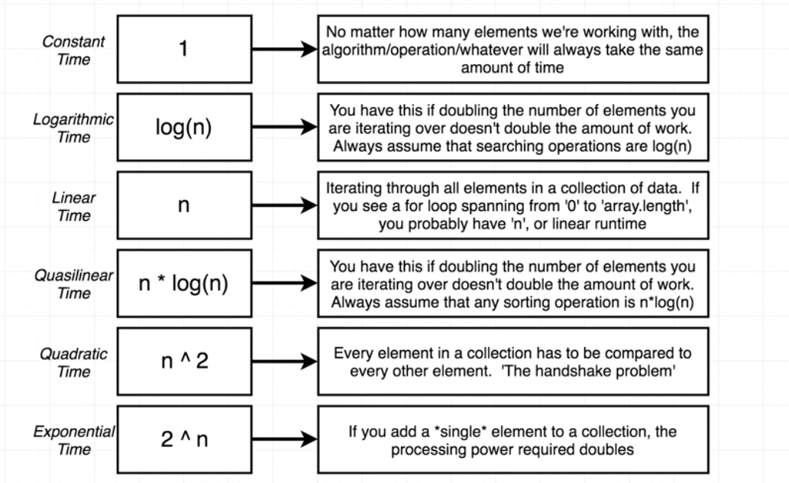

a) Constant Time: 1
- No matter much we increase the input, the time taken to complete is always the same.

b) Logarithmic Time: log(n)
- Time to complete, will not double if we double the input. Searching algos are log time.

c) Linear times: n
- Time to complete is directly proportional to the number of input.

d) Quasilinear time: n*log(n):
- Increasing the input set by 1, increases the time to complete to 1 + a little bit. Many sorting algos are n*log(n)

d) Quadratic time: n^2:
- Increasing the input significantly increases the time taken to complete. Here each element has to interact with every other element in the collection.( for example: adding a new guy in a group and that new guy has to shake hands with everyone in the group).

d) Exponential time: 2^n
- Increasing the input, significantly significantly increases the time to complete. Don’t come up with solutions have exponential time complexity in interview.

Big O Notation:
- Is a Way of referencing the run time complexity (efficiency).
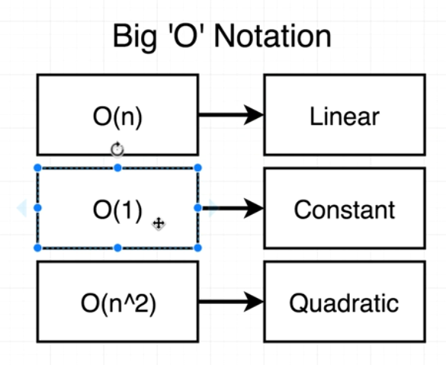

3. Identifying Run time Complexity:
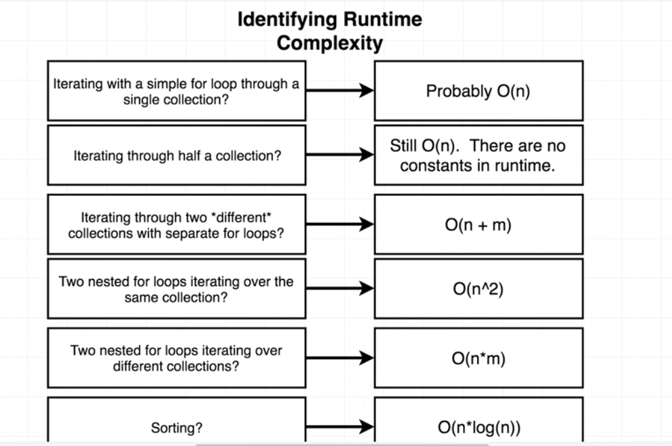

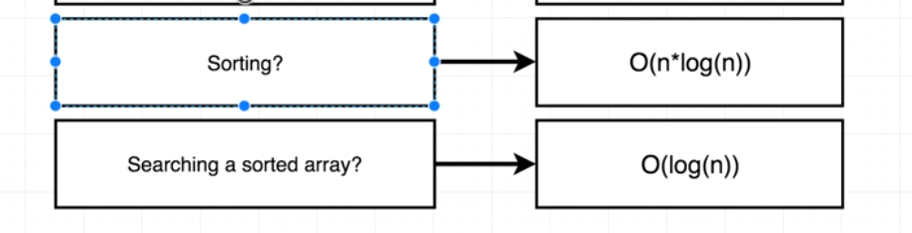

Space Complexity of an Algorithm:
- Reference to how much RAM, memory or space an algorithm would require.
- This complexity is referenced similar to Time complexity.
- For example, amount of space required to reverse a string in linear run time.

